Business Process: Insert Campaign

Contact
Business Process Owner | Billing Solutions
Subject Matter Expert(s) | Customer Service Assistant & Revenue Analyst
Key Contact | Billing Manager, Billing Supervisor
Key Role | Customer Service Assistant & Revenue Analyst: manages monthly bill insert campaign
Date Created | 4/22/2026

Business Process Overview

SMUD utilizes monthly bill inserts as a key communication channel to inform customers about SMUD programs, initiatives, rate changes, and energy savings tips. These inserts are included with customer bills and are primarily targeted at residential customers, though commercial customers may also receive them.
To ensure customers receive these inserts, SMUD follows a defined process:
- Campaign Initiation: An Insert Campaign is created for each communication effort, specifying the content, target audience, and timing.
- Vendor Coordination: SMUD works with its print vendor, using the Doc Web console to enable and manage the campaign. This involves configuring the relevant settings so that the inserts are included in the proper bills.
- Print File Preparation: SMUD includes specific insert codes in the bill print files sent to the vendor. These codes identify which inserts should be attached to each customer’s bill based on campaign parameters.
- Bill Production & Distribution: The vendor prints and assembles the bills with the designated inserts, ensuring customers receive the appropriate communications.
This business process ensures that SMUD effectively communicates important information to its customer base, supporting engagement, awareness, and informed energy choices.

Business Process Assumptions, Prerequisites, Dependencies
(Assumptions pertaining to the business process)
People | - Customer Assistant & Revenue Analyst from Billing is responsible for tracking, inputting insert data, approving and working with Vendors and IT to ensure inserts are mailed to customers monthly
Process | - Monthly insert campaign must be moved to Production before monthly bill cycles begin
Technology | - Kubra Doc Web is used to create and submit monthly insert campaigns  - IT updates inserts into SAP via Service Now Ticket

Process Flowchart
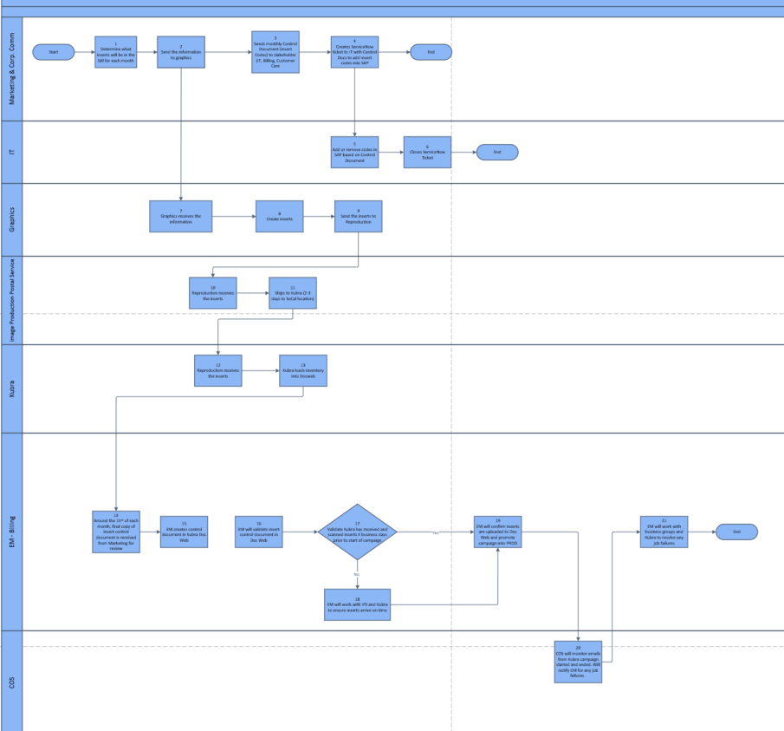

Task Description
Id | Task Description | Procedure
1 | Determine what inserts will be in the bill for each month | Marketing will determine what monthly inserts go out each month
2 | Send the information to graphics | Marketing sends design request to graphics to create inserts
3 | Sends monthly Control Document (Insert Codes) to stakeholder (IT, Billing, Customer Care | Marketing sends monthly control document to stakeholders with planned inserts
4 | Creates ServiceNow ticket to IT with Control Docs to add Insert codes into SAP | Marketing creates service now ticket to IT to update insert codes into SAP
5 | Add or remove codes in SAP based on Control Document | IT will update codes for each inserts in SAP database
6 | Closes ServiceNow Ticket | IT will add note and close tickets once completed
7 | Graphics receive the information | Information for graphics received from Marketing team
8 | Create inserts | Graphics will create requested inserts from Marketing
9 | Send the inserts to Reproduction | Once graphics completes insert design, they will send to IPPS
10 | Reproduction receives the inserts | IPPS received inserts from graphics and packages for shipping
11 | Ships to Kubra (2-3 days to SoCal location) | IPPS will ship to Kubra to ensure inserts are received prior to start of monthly insert campaign
12 | Kubra receives the inserts from IPPS | Kubra will receive inserts from IPPS at their southern CA location
13 | Kubra loads inventory into Docweb | Kubra will prep inserts and upload pics of each insert into Doc web
14 | Around the 15th of each month, final copy of insert control document is received from Marketing for review | Marketing emails stakeholders including EM in billing the monthly insert updates
15 | EM creates control document in Kubra Doc Web | EM will create control document in QA environment of Docweb for each month
16 | EM will validate insert control document in Doc Web | EM will have second person validate the inserts match the information from the monthly control document
17 | Validate Kubra has received and scanned inserts 4 business days prior to start of campaign | EM will have a reminder to ensure inserts have been updates on Docweb QA. If not, they will work with IPPS and Kubra to ensure insert arrive on time for uploading
18 | EM will work with IPS and Kubra to ensure inserts arrive on time | Once EM validated inserts have arrived at Kubra and uploaded into Docweb QA, they will move changes to DocWeb Production
19 | EM will confirm inserts are uploaded to Doc Web and promote campaign into PROD | EM will monitor start and end of inserts. Email should arrive from Kubra to validation.
20 | COS will monitor emails from Kubra campaign started and ended. Will notify EM for any job failures | If COS receives any file error, they will notify billing to follow and resolve any issues
21 | EM will work with business groups and Kubra to resolve any job failures | EM will work with Kubra, IT and COS to resolve errors. If error causes a delayed start of monthly campaign, EM will work with Marketing on next step plans.

Business Rules
Id | Event Name | Business Rules
15 |  | The insert campaign will run starting with cycle 1 and ending with cycle 21
15 |  | The campaign will apply to bill inserts and remittance envelopes only
15 |  | The insert campaign will be created prior to the cycle 1 bill date
15 |  | The campaign dates must mirror the print vendors processing dates  o Bill files are processed the day after their bill date  o Bill files that bill on Friday are processed the following Monday
15 |  | Insert inventory must be created in the PROD environment prior to setting up an insert campaign
15 |  | The insert campaign will be set up in the PREP environment and then promoted to the PROD environment
15 |  | The Outer Mailing Envelope determines if the bill package is advertising or non-advertising  o Residential bills are generally included in the advertising campaign  o Commercial bills are generally included in the non-advertising campaign
15 |  | The print vendor will handle the set up for the Outer Mailing Envelope (OME)
15 |  | KUBRA Insert codes are to be set up at the beginning of the year for the entire year and provided to Marketing
15 |  | If non-advertising envelopes are used for all bills then the insert campaign set up must match for all 4 splits

Event | Legal Requirements, Rules, and Regulations  Legal documents/ procedures/ requirements to be fulfilled before/at the specified event.
Id | Event | Legal Requirements, Rules and/or Regulations

Departments impacted by process change (Required)

Department | Type of Change(s) | Action Required
Billing | S4Hana | TBD

Supporting Documentation
(Any subsequent documentation in support of this business process (i.e. business requirements, technical specs, etc.) shall be summarized in the following table.)
Document Type | Link
Process and Procedure Document | Insert Campaign.pdf
 | Insert Campaign Process Map.vsdm

Business Blueprint Amendments

Any subsequent changes to this business process blueprint after the official document approval shall be summarized in the following table. This document must be reprinted and signed by the authorized representatives.
Version | Author | Description of Change | Approval (Name/Sign) | Date
V1 | Derek Yamamoto | S4Hana Migration | Ginny Broidy | 04/23/2026

